# **MySQL NDB Cluster Configuration in Ubuntu 22.04 LTS–Step by Step process**

**Prerequisites :**

Server Usage Type Public/Internet IP address Node ID

Management node 192.168.32.149 1

Date node 1 192.168.32.150 2

Data node 2 192.168.32.151 3

SQL node 192.168.32.152 4

Configuring 4 nodes :

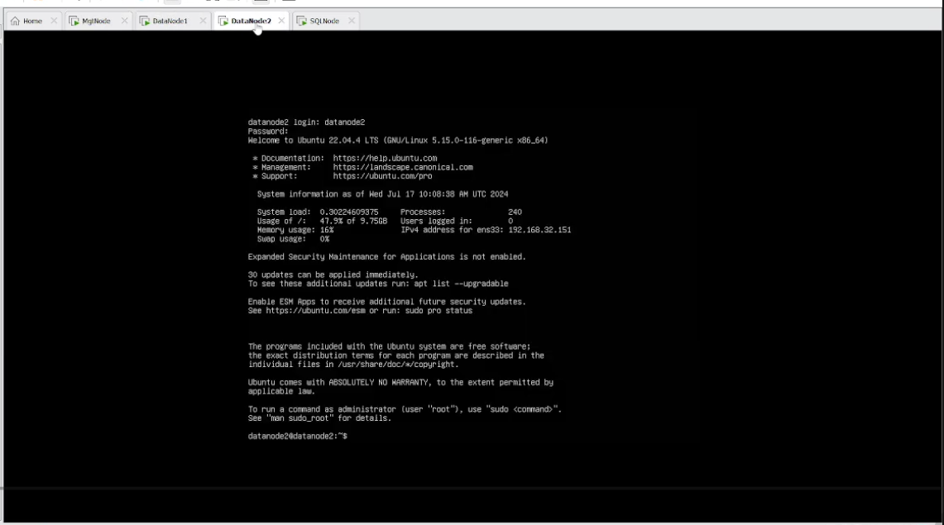

Step 1: Defining MySQL NDB Cluster Management Node (ndb_mgmd)

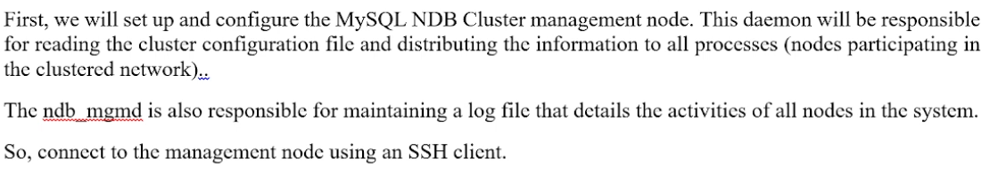

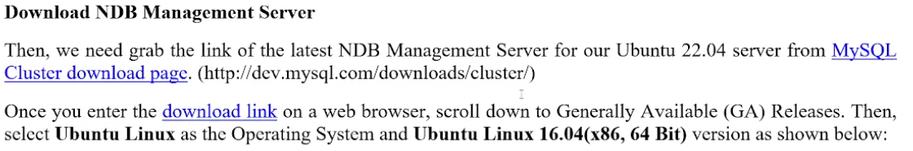

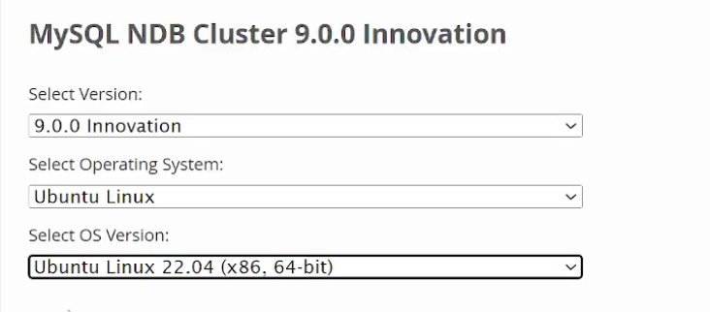

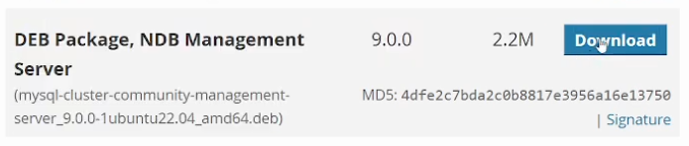

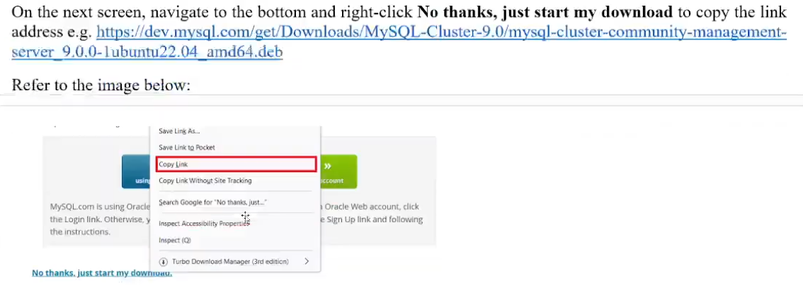

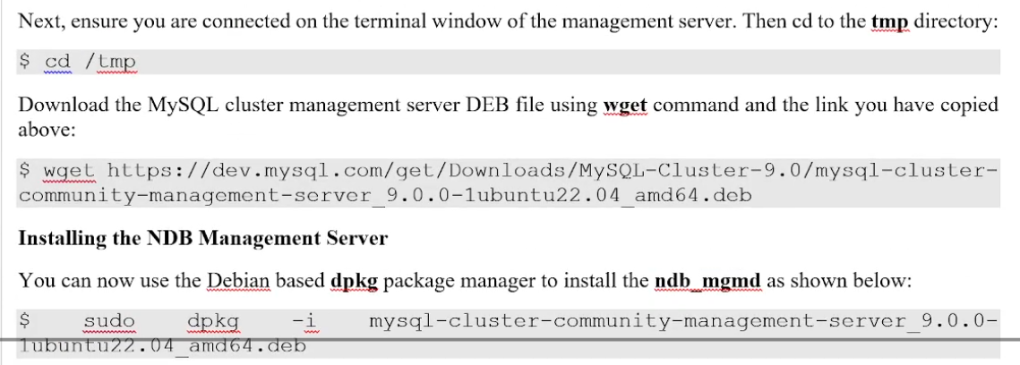

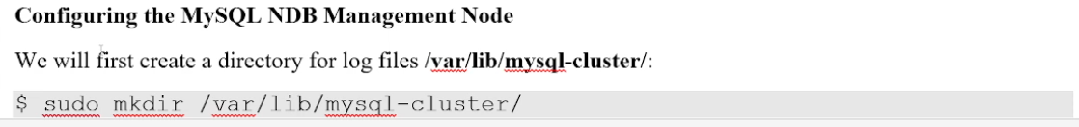

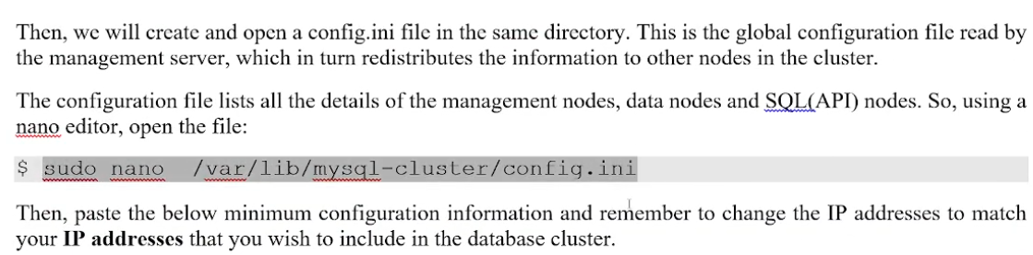

In below we have change ip according to server

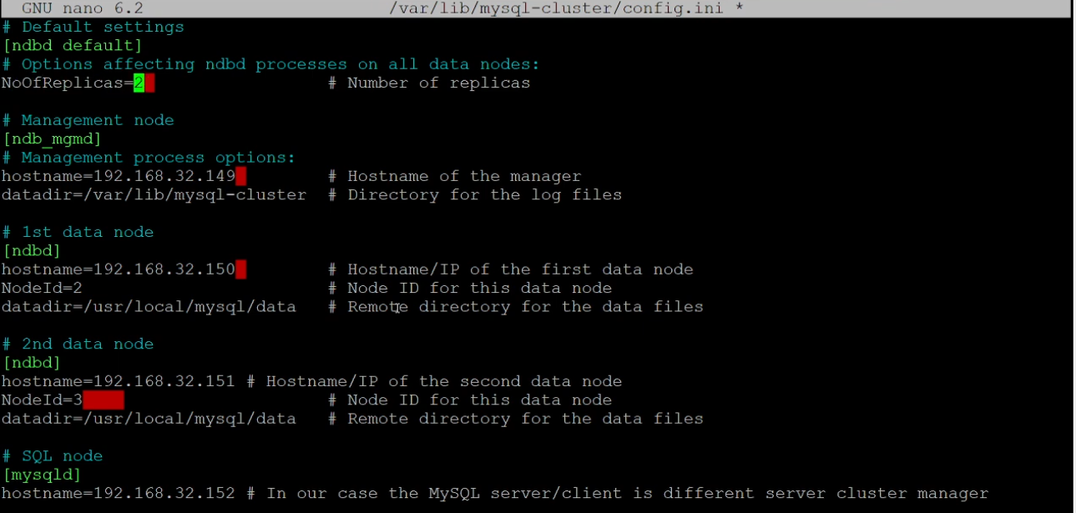

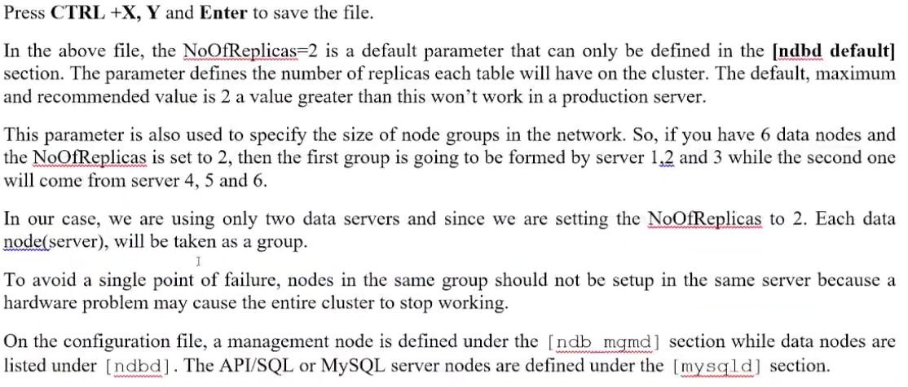

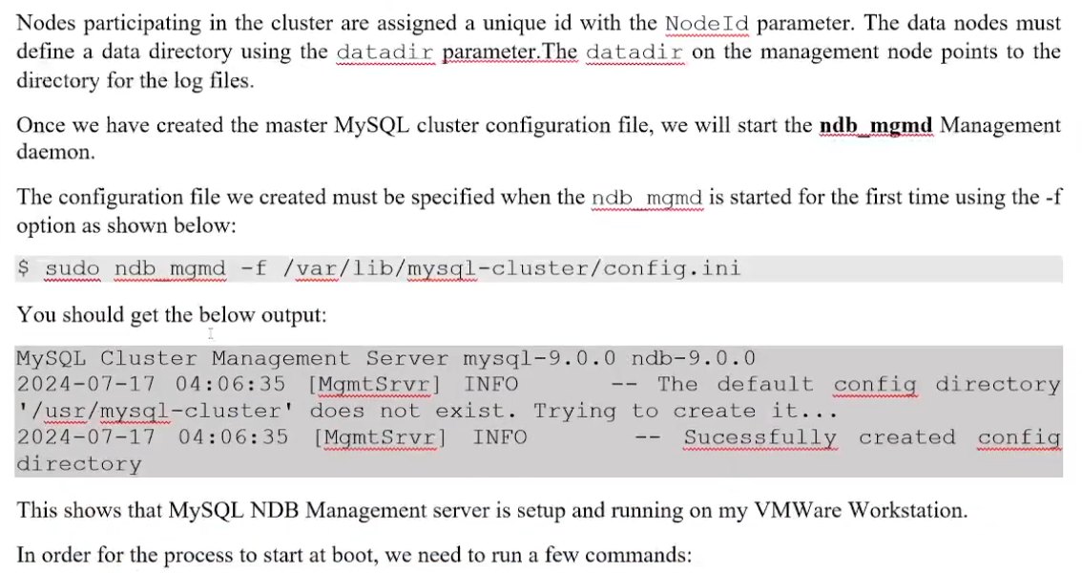

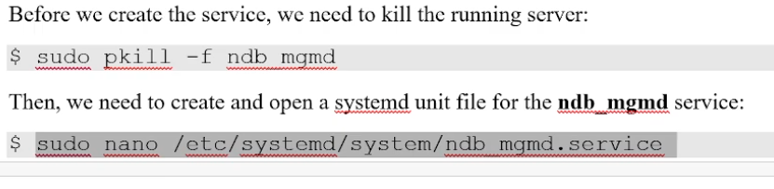

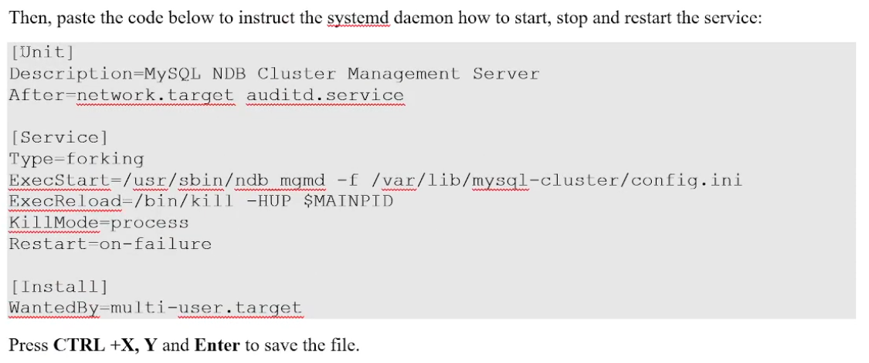

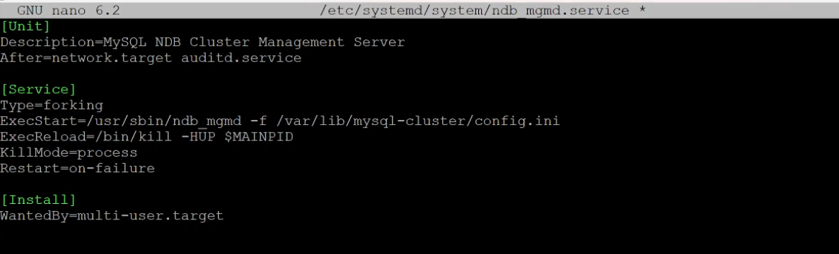

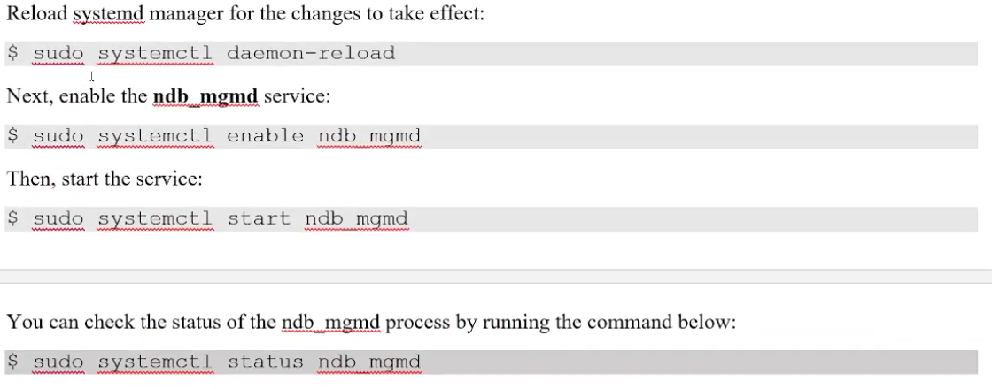

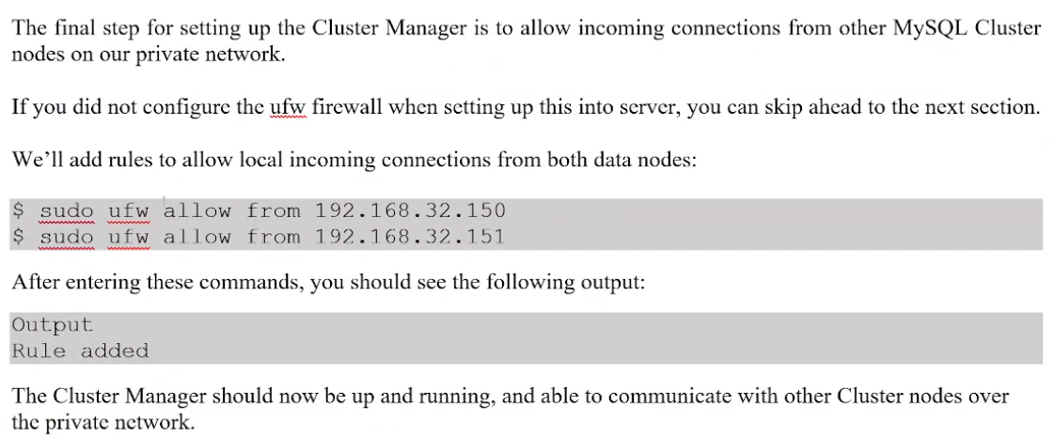

Step 2: Configuring MySQL Cluster on Data Nodes

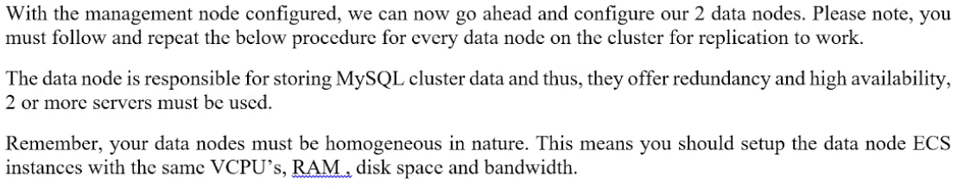

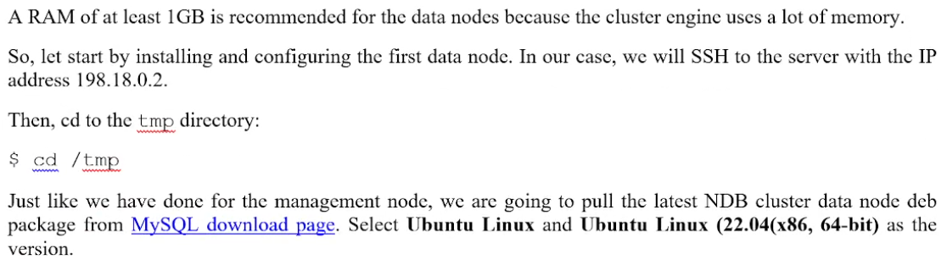

Connect datanode1 and datanode2

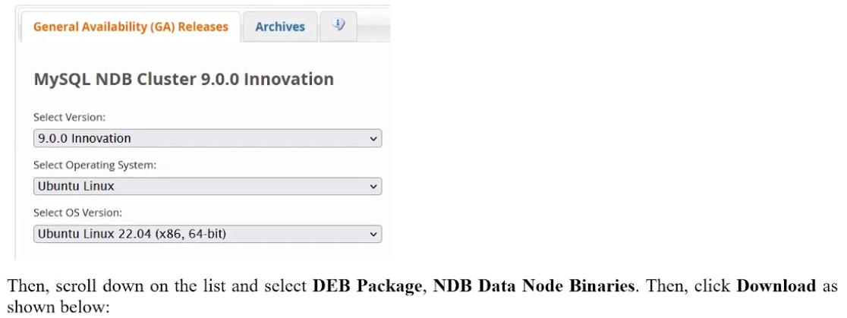

Download the package

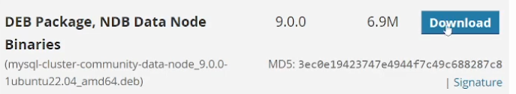



Paste the link and download using weget



After download and install update using apt update on both datanode1 and datanode2

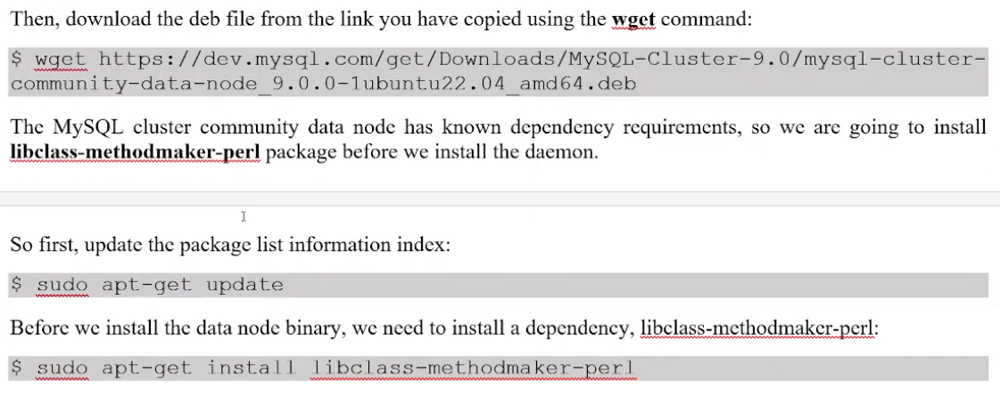

Now next step to install the Mysql cluster on both datanode1 and datanode2 :

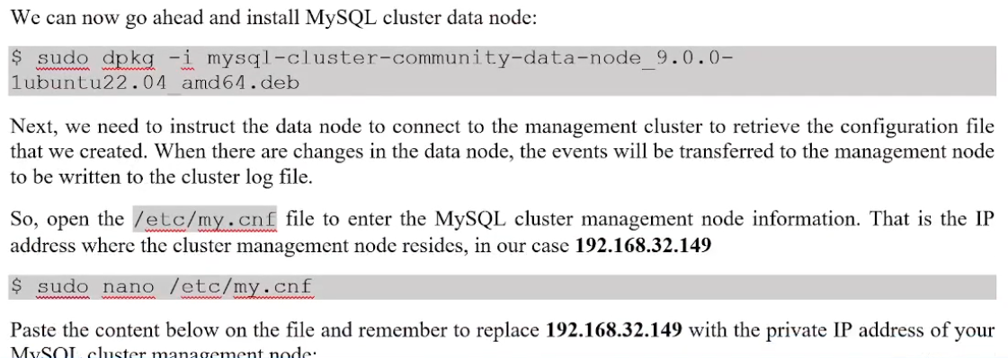

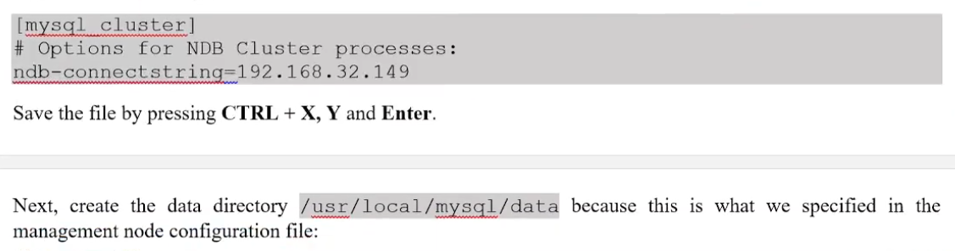

Example :

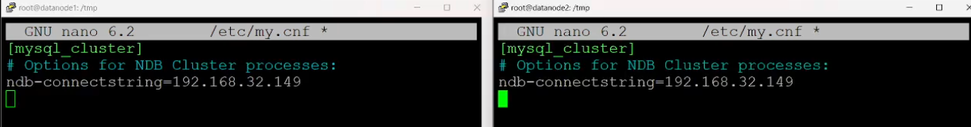

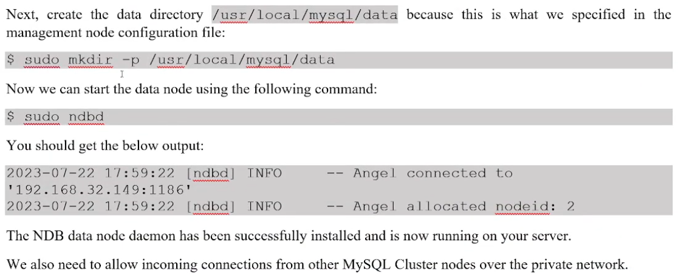

Start the ndbd node in both node1 and node2 id .

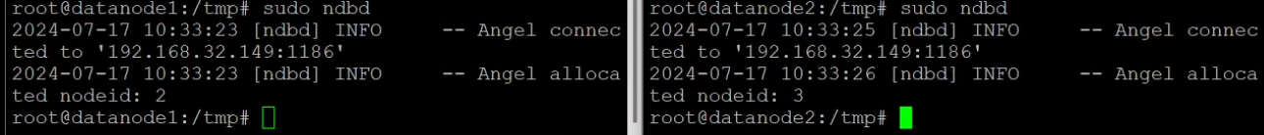

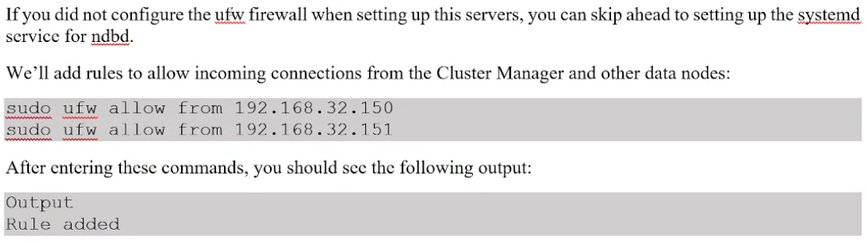

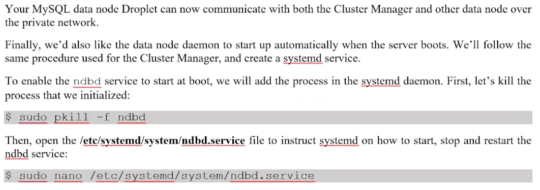



Now next open in both node file sudo nano /etc/systemd/system/ndbd.service

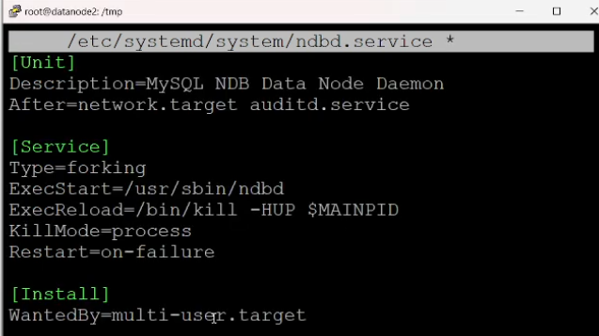

Run below on both node

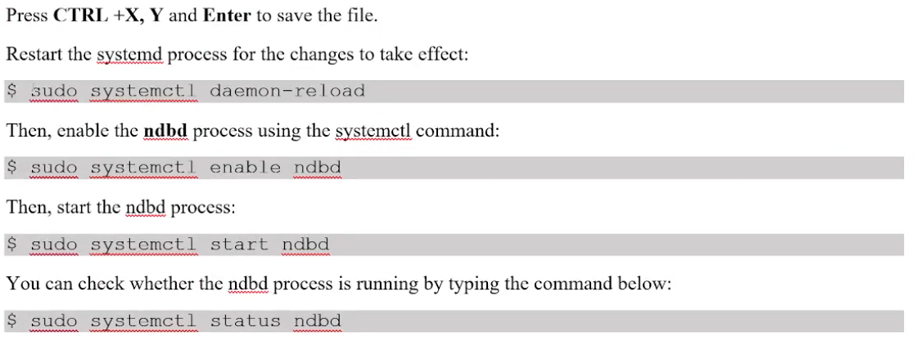

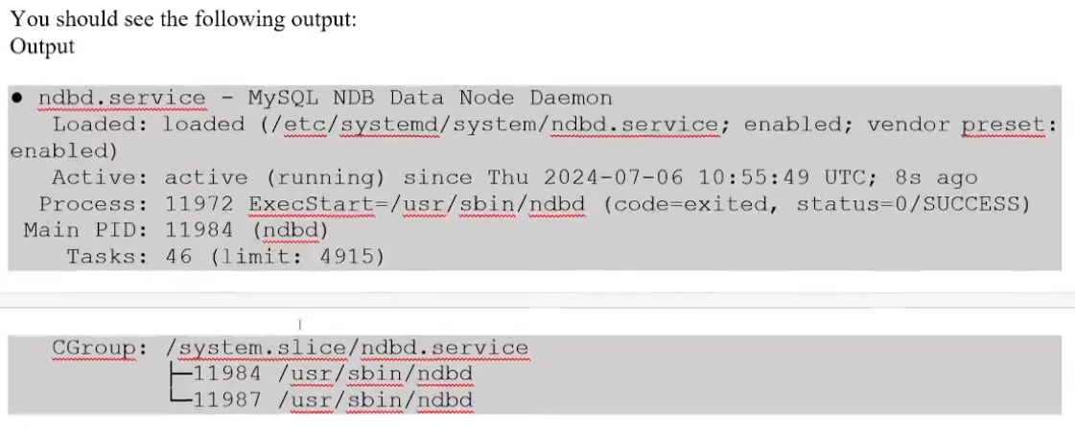

Step 3: Configuring SQL Cluster Node

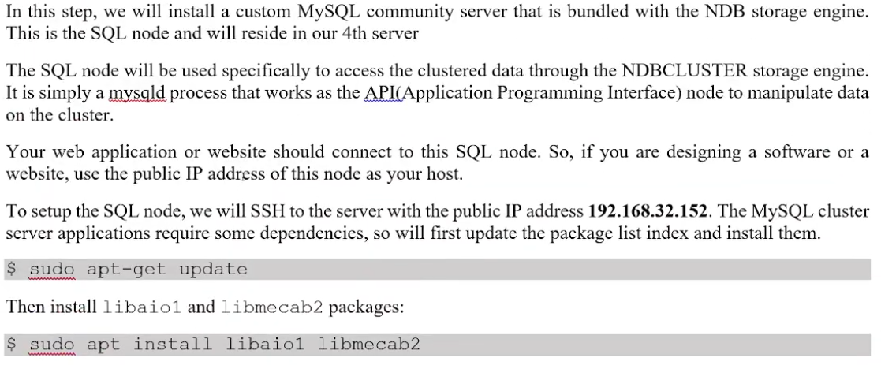

Press Y and hit enter when prompted to confirm the installation

Then , cd to the tmp directory on the server .

$ cd /tmp

Download the Mysql Cluster DEB bundle link from Mysql cluster download page select ubuntu linux as the operating system as the version .

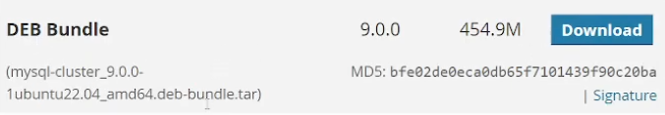

Select appropriate bundle and click on download and right click and copy the url link and now follow the below steps .

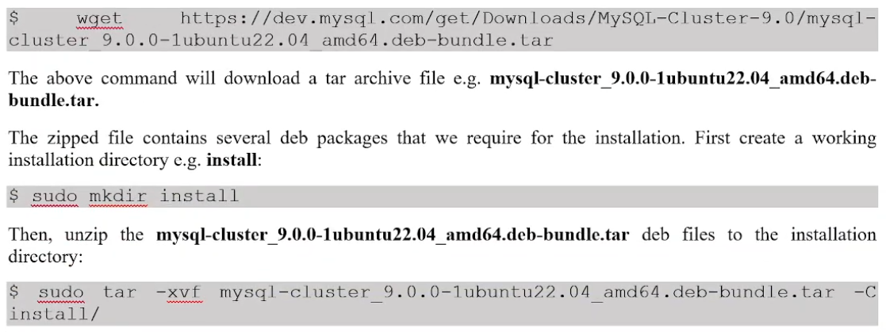

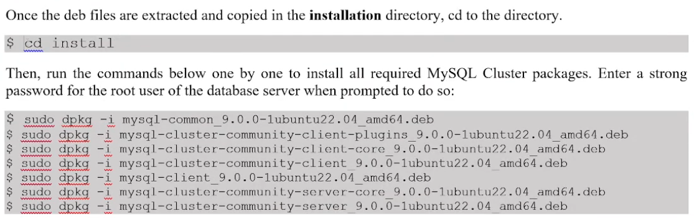

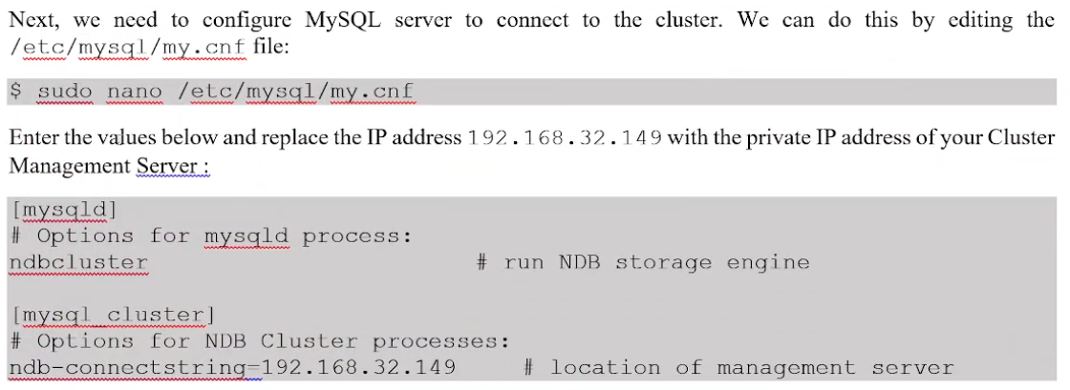

Add in sqlnode my.cnf ip of ndb server

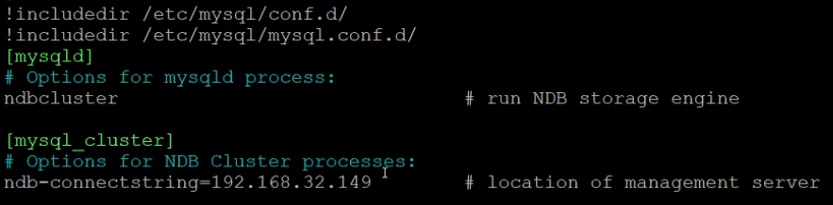

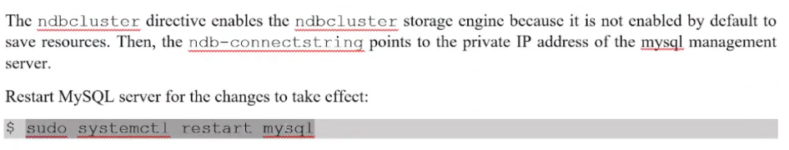

Step 4: Verifying MySQL Cluster Installation

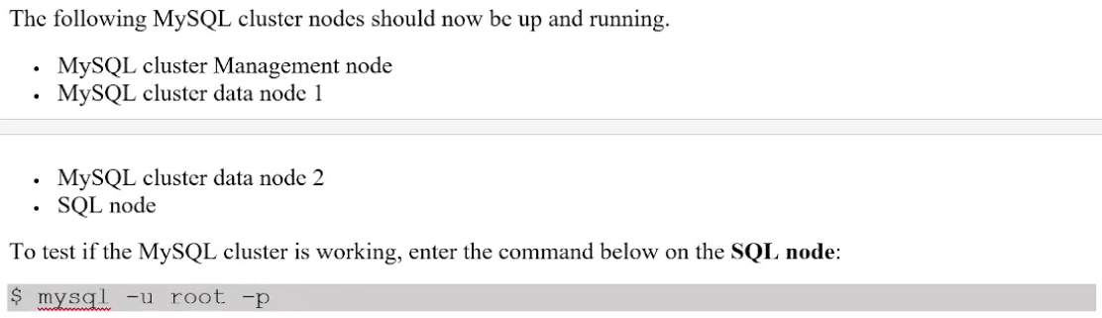

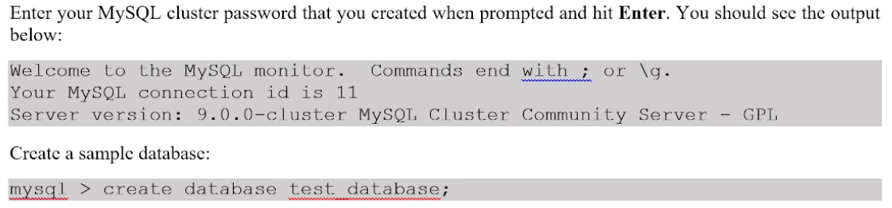

Now create table in this database and insert some records .

Once inside the mysql client run the following command

Mysql> SHOW ENGINE NDB STATUS \G;

And connect ndbd and perfrom activity.